REVISION ARTS TEA PARTY 2020 – AUCTION ITEMS ***Instructions are at the end of this document***
ITEM # | ITEM DESCRIPTION | MINIMUM BID | PICTURE
1 | Lavender Art Glass Bowl –  Oh, this is for you!!! Grace your home with this beautiful lavender decorative glass bowl! It is 5 ¼” high, and the brim is 19” wide. So very versatile…whether used as a planter, flower bowl, for food, or set on a pedestal as an art piece! Stunning!! | $75 | 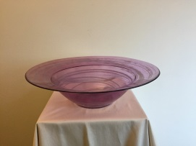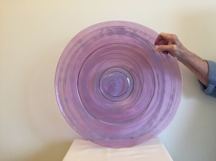
2 | Lake Chelan Weekend Get Away –  You will for sure want a weekend away at Lake Chelan in north western Washington State!! Spend three days and two nights in this lovely condo which is close to the lake, making this the perfect, “get away,” destination from the big city!! This fabulous condo sleeps six and is across the street from the State Park and the main beach. Includes one parking space.  The winner will be notified and given the owner’s email address. She is asking for an email back ASAP in order to reserve your 3 days. She will need to check availability…so have several options available for her!  More condo pics | $350 |   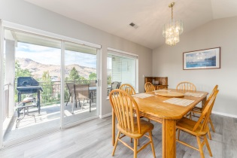  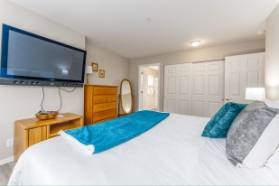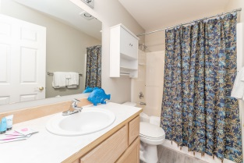
3 | “Grown Up and Me” Matching Floral Aprons with Book –  Get cooking with your favorite, “Little!” Here we have a, “Grown Up & Me,” set of matching aprons! These cheery, colorful aprons are Misses size large and Child size large. They are made of 100% cotton fabric, so they are easily washed. The multicolor floral body is perfectly complemented by a beautiful turquoise bodice and hem border, with pink pocket trim. They come with both, “Mrs. Potts and Chip,” buttons (from “Beauty and the Beast”) as well as, “Mrs. Potts and Chip,” iron on patches, if your tot is not safe with small buttons. The Sewist will send both with this set, and you can choose which you want on yours and your youngsters aprons…so, “some assembly required,”…affixing either buttons or the iron on patches to the bodice of the aprons! These treasures will make any foray into your next culinary adventure with your favorite tiny chef, “Magnifique!” Bonus – They come with the book, “Angelina Ballerina And the Tea Party!” | $75 | 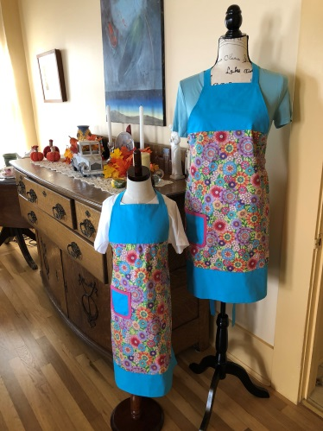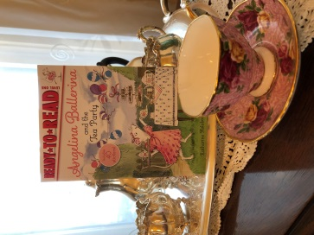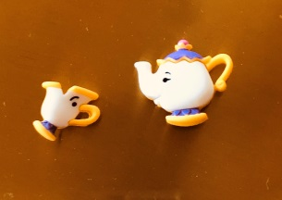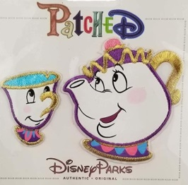
3 | “Grown Up and Me” Matching Llama Aprons and Book –  And look! A second set of, “Grown Up and Me,” matching aprons! This time in Misses size medium and child size medium. Again, made of 100% cotton, in a fabric adorned with colorful, happy llamas on a contrasting black background! The llamas make up the body of the aprons, with a bright green with orange, red, yellow, and purple tiny dots for the bodice and hem border, and bright orange pocket trim. These aprons come with both a, “Llama in a Teacup,” pin to adorn the bodice, or an iron on Llama patch, if your youngster is not yet safe with pins. The Sewist will send both, for a you to choose! So, “some assembly required,”…affixing either pins or the iron on patches to the bodice of the aprons! These aprons will make you and your, “Little,” a winning duo in the kitchen as you whip up your favorite, “Muy Bueno,” recipes! Bonus – They come with the book, “Is Your Mama a Llama?” | $75 | 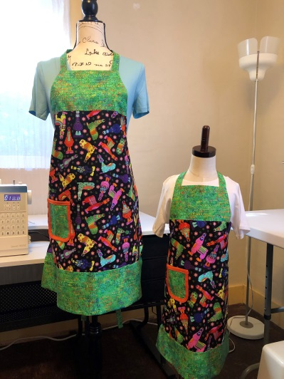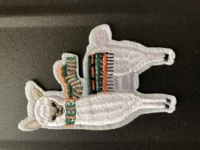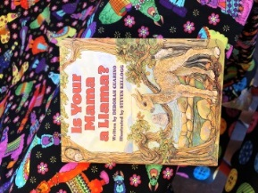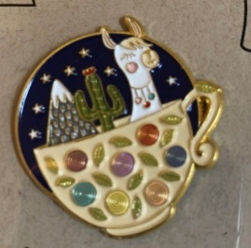
4 | Turkish Mandala Bowl –  Give your home that exotic vibe! This beautiful glass bowl, made in Turkey, brings a Middle-Eastern flare to any table. This bowl is decorated in turquoise and purple glaze, and embellished with gold toned raised lines. It is 12” across and 2 3/4” deep. Versatile uses – perfect for dinner parties or to just keep on display as a 3D piece of art! A lovely mandala for you to enjoy! | $30 | 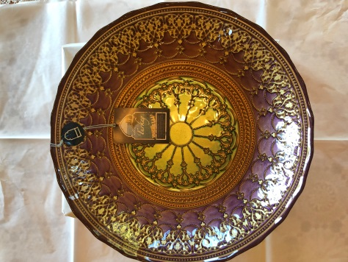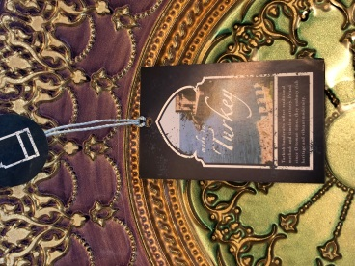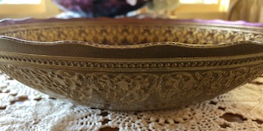
5 | “Touching Moments” Wall Calendars –  Get your own, “Touching Moments,” 2021 wall calendar! Designed by our very own Barbara Oswald, award winning photographer, and adorned with a selection of her stunning photographs. Unlimited quantities, so this is perfect for all of your special peeps, as Christmas or Hanukah gifts!! Your garden will bloom all year long!!! | $20 each | 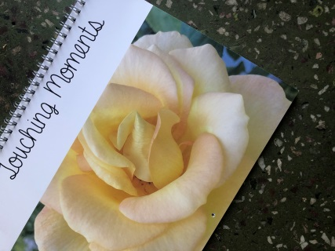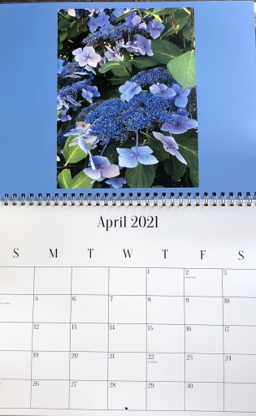  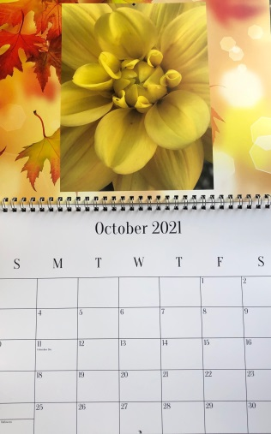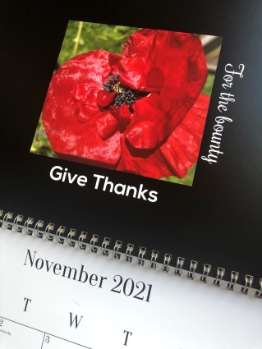
6 | Hand Made Country Quilt –  This warm and cozy quilt is sure to be treasured for many years! Hand quilted by 90 year old Jean Wilson (aka “Grams”), a highly skilled quilter extraordinaire, in 2006! No machine work on this quilt…panels hand quilted and sewn together, borders hand sewn in place! This piece of fabric art is 42” x 50” – big enough to be a throw for your couch or favorite easy chair, and beautiful enough to be a piece of art as a wall hanging! It is sturdy, and holds up to cold water wash in the machine beautifully! Good news…there are two available!!!! These quilts have never been used, and have been stored since they were created. They are certain to become family heirlooms!! | $200 each | 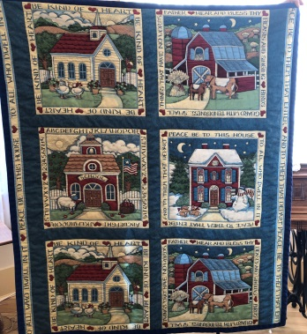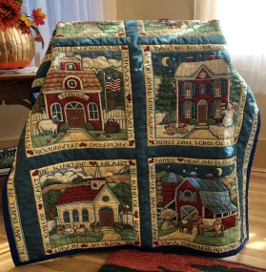
7 | Cranberry Scented Hand Soap & Lotion with Towels -  Spruce up your bathroom for the Holidays! Cranberry scented hand soap and lotion – both utilitarian and beautiful!! And, to complete your bathroom, sweet and useful fingertip towels, adorned with lovely holiday wreaths!! Soap and lotion each contain 16 ounces, and are 7” tall. The ceramic tray is 7 ¾” x 4 ¾”. The two fingertip towels are 18” x 12”. Perfect for the Holidays!! | $25 | 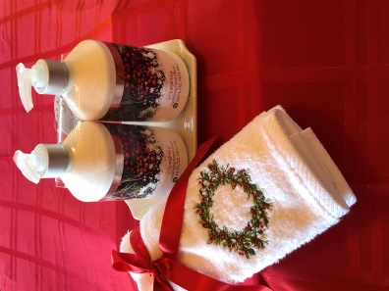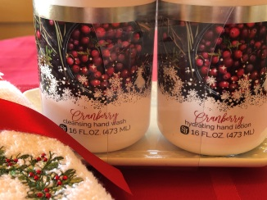
8 | Holiday Placemats and Napkins –  These are just perfect to bring the Holidays to your table! The 4 red, green and white plaid placemats are 19” x 13”. The 4 matching napkins are 16” x 16”. Both have a lovely gold toned thread running through to, “dress up,” their look! | $25 | 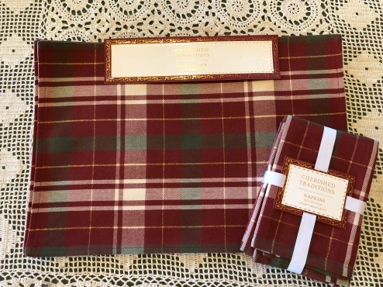
9 | Beach Flamingo Tray and Towels –  Dreaming of the Beach??? If so, these Pink Flamingos are sure to bring a bit of summer to your life! The Tea Towels are adorned with darling Flamingos, complete with pink fluffy bodies!! Gosh…with the sentiment on the towel, this might make a perfect Mother’s Day Gift!!! | $20 | 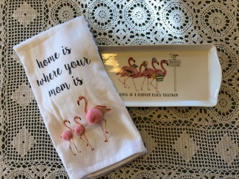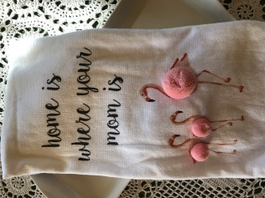  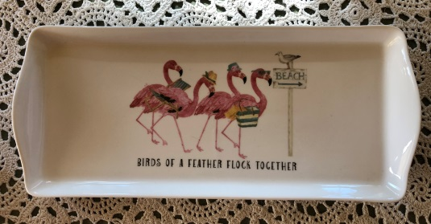
10 | Two Tiered Tea Treat Tray –  Tea, anyone??? This beautiful, sparkly two tiered Tea Treat Tray is just waiting to be loaded up with cranberry scones…oh and you get a scone mix, too! Upper tray is 8”across, and the bottom tier is 11” across. It stands 12” high. This glassware item was made in Turkey, and will bring an exotic beauty to any table! | $30 | 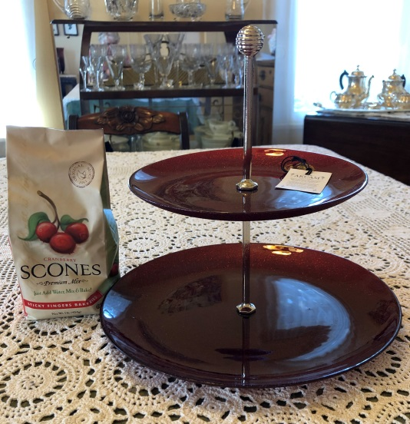
11 | Royal Worcester Serving Dish –  Such a lovely, antique ceramic serving dish! It was made by Royal Worcester in England!! Beautiful ripe fruits and vegetables decorate this piece, and it is trimmed in gold tones. It has never been used! It is 8 ½” across externally, and 8” across internally. The bowl depth is 2 ¼”, and 3 ¼” with the lid on. It is oven proof. A lovely oven to table bowl! | $75 | 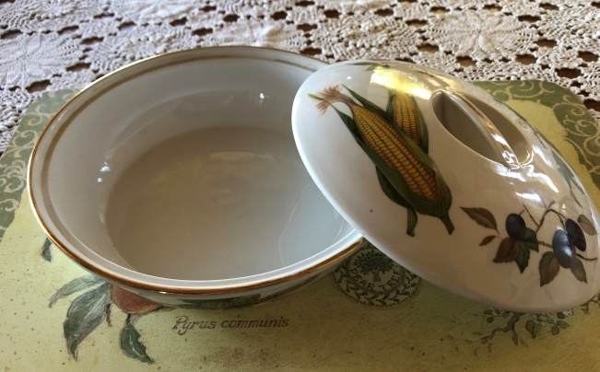  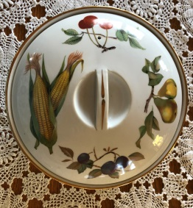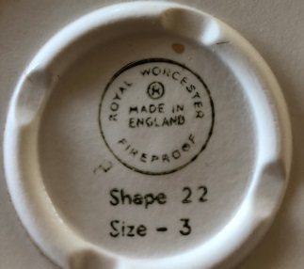
12 | Santa Tea Set –  Have tea with Santa!! This darling set comes with a tea pot, a demitasse cup and saucer, and a ceramic tray! A lovely set of Holiday Plaid tea towels accompany the set! The teapot is 4 ½” high without the lid, and 6 ½” with the lid; the demitasse cup is 3” across, and 1 ½” deep; the saucer is 4 5/8” across (it is slightly irregularly shaped…purposefully) x 4 ¾”; the tray is 12 ½” x 6 ½”. There are one plaid and one plain towel – 28” x 18”. And to complete this tea set is a box of Walkers shortbread cookies…perfect!!!! | $35 | 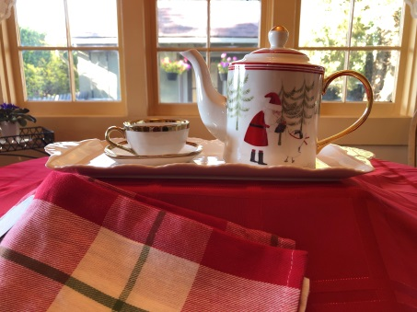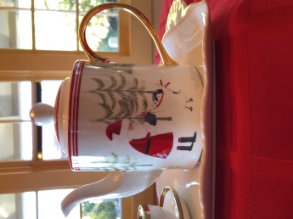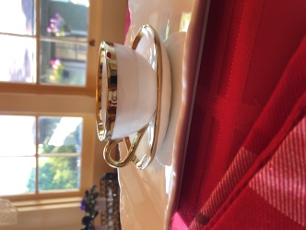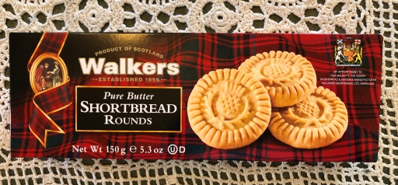

Bidding - starts at 3:30pm on October 24, 2020, and will end at 11:59pm on October 31, 2020.
How to Bid – Email your bids to Kathy McNutt at kmcnutt.revisionarts@gmail.com.
Include in your email –
- The number of the item you want to bid on
- The description of the item (for the calendars, how many you want…remember your bid is PER CALENDAR)
- The dollar amount of your bid
- Your name
- Your mailing address
- Your phone number

If you are bidding on more than one item - please send each bid in a separate email
Winning Bids – The highest bid wins the item. If there are two bids for the same amount for the item, the winner will be the first bid received for that amount.

Thank you so much for your support of ReVision Arts!!!

