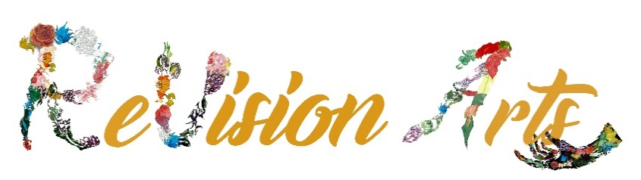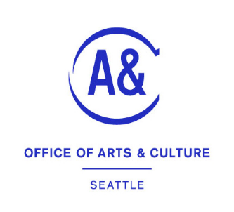

Arts & Culture Neighborhood Recovery Program

Guidelines

(Required to read prior to submitting application)

The Arts and Culture Neighborhood Recovery Program is a City of Seattle Office of Arts & Culture (ARTS)-funded program to provide grants for arts and cultural events/projects in neighborhoods through community-based organizations. Events/projects must be open to the public. There are 14 lead organizations focused on neighborhoods or communities throughout Seattle.
Cultural events, experiences, and spaces provide the reason for people to gather, confer, identify, and build community. Critically important during the current COVID pandemic and recovery process, this program seeks to support recovery efforts through collaboration, equity, resiliency, and safety in alignment with the City of Seattle’s vision of One Seattle.
REVISION ARTS as the Lead organization for the RAINIER VALLEY, shall sub-contract to neighborhood-based organizations and small businesses to carry out inclusive and creative arts and culture endeavors that further the city’s pandemic recovery process. Applicants must conduct events/projects within this neighborhood or community.
These projects/events seek to reach underserved communities and audiences and those most impacted by COVID-19, in particular, BIPOC (Black, Indigenous, People of Color), low-income, and under-served communities. Projects/events should seek to rebuild and assist in arts and culture recovery; events do not need to be entirely new events.
The total amount of funding available through ReVision Arts for Rainier Valley is $72,000.
Projects/events of all sizes are welcome not to exceed $18,000.

Who is Eligible?
- Non-profit organizations (arts and culture, and others) focused on events/projects within the Rainier Valley.
- Small businesses with a City of Seattle business license. However, a small business owner who is a sole proprietor can apply but must collaborate with other individual artists or others for the proposed project (for example: projects can fund a group of musicians, but not a solo act).
- Applicants can apply to more than one Lead Organization for this city-wide program. However, they can receive funding from only one lead organization (see list of other Lead Organizations at end of this document).
- Applicants should be place-based in the Rainier Valley and should have a history and track record of direct connection to the arts and cultural life of the Rainier Valley. Applicants do not need to have their primary address in the Rainier Valley. However, the projects must be within the Seattle city limits and those who live and/or work in the Rainier Valley will have priority.
- Projects/events must be broadly advertised and accessible to the public. Free event admission is preferred, or using a low-cost or sliding fee scale, and events should be physically accessible.
- Applicants must have the capacity to successfully manage the proposed project, prepare regular reporting, and complete final reports due no later than September 6, 2023.
- All events shall provide event liability insurance and name ReVision Arts and City of Seattle as additionally insured (event insurance is easily obtained, ask ReVision Arts for assistance).
- Awarded programs will be required to follow all current Federal, State, County, and City COVID-19 mandates and protocols. More information and in other languages are available on the City of Seattle COVID-19 Vaccination Requirement website.

Funds May Be Used For:
- Costs directly related to event/project (staffing, equipment rental, paying performers, materials, etc.)
- Examples (sample) of public projects or events:
  - A series of performances at an indoor or outdoor venue
  - Temporary public art or lighting (permit/approval must be secured prior to award)
  - Festivals, fairs, or public events (can be for specific part of a larger event)
  - Art exhibits, such as “Please Touch”
  - Art or cultural workshops or classes, such as designing arpilleras or alebrijes.
Funds May Not Be Used For:
- Events held outside Seattle city limits
- Capital improvements or purchase of equipment
- Travel costs (local transportation costs for performers, for example, are ok)
- Religious events
- Programming in which fundraising is the primary purpose.
- General operating expenses.

Criteria:
- Criteria 1: Strength of Project and Relationship to Neighborhood/Community (25 Points)
- Criteria 2: Community Building, Outreach, and Accessibility (40 Points)
- Criteria 3: Americans with Disabilities (10 Points)
- Criteria 4: Background and Capacity (25 Points)

Timeline
January 10-February 28, 2023 | Application period and assistance available from ReVision Arts staff (includes Guidelines, Application, & Budget Template)
March 1, 2023 | Application deadline. (ReVision Arts may begin reviewing applications that are submitted prior to the deadline.)
March 1-15, 2023 | Review panel meets to discuss each application in relation to the program criteria and make funding recommendations.
March 16-31 2023 | Applicants are notified whether they have been recommended for funding, are contracted with, and event/project planning can begin.
April 4  April 10-August 31, 2023 | Subrecipients Orientation  Awardees carry out arts and cultural events.
September 6, 2023 | Awardees submit their reporting documents to ReVision Arts and final report due no later than September 6, 2023.

Application Tips
All funding programs can be highly competitive. We encourage you to:
- Read these guidelines, check your eligibility, and follow the instructions carefully.
- Explore the application early so you can plan ahead.
- Update Seattle Business License, if needed. HERE
- Be clear and concise in your application. Panelists read and evaluate many applications.

Obligation of Award Recipients
Acknowledgement
Organizations and individuals receiving awards from ReVision Arts and funded by Seattle Office of Arts & Culture (ARTS) must acknowledge ReVision Arts and City of Seattle’s support in printed materials, signage visible to the public, via social media, or in other ways appropriate to the project. ReVision Arts and Seattle ARTS will supply preferred wording and logos in electronic format.
Payment/Reporting
Regular reports and final reports and invoicing will be due as per the contract schedule and negotiated with ReVision Arts. Reports shall include data (demographic, # of people attending, etc.) and narrative as outlined in the contract. ReVision Arts will provide each subcontractor with the methodology and necessary data collection details required by the City of Seattle.
For additional information, contact: Barbara Oswald, boswald.revisionarts@gmail.com, Text or call: 206.734.1994

LIST OF OTHER ORGANIZATIONS/AREAS SERVING AS LEAD ORGANIZATIONS:
AFRICATOWN COMMUNITY LAND TRUST: Central Area
BEACON ARTS: Beacon Hill (including Mt Baker)
DELRIDGE NEIGHBORHOODS DEVELOPMENT ASSOCIATION: Delridge, Highland Park, Westwood (north of SW Roxbury)
DOWNTOWN SEATTLE ASSOCIATION: Downtown
FRIENDS OF WATERFRONT SEATTLE: Waterfront
GAY CITY HEALTH PROJECT: Capitol Hill
GEORGETOWN CDA: Georgetown and South Park
HISTORIC SOUTH DOWNTOWN: Pioneer Square and Chinatown/International District (including Little Saigon and Japantown)
LAKE CITY COLLECTIVE: North Seattle (specifically Lake City, Greenwood, Northgate, Bitter Lake, and Aurora, north of 85th)
MUSEUM OF HISTORY & INDUSTRY: South Lake Union
NA’AH ILLAHEE FUND: City-wide
SOUTH END SEATTLE ART CENTER: Rainier Valley
UDISTRICT PARTNERSHIP: University District
WEST SEATTLE JUNCTION: West Seattle Junction

